**Write up**

Chen (3100464)

Xinran Zhi(2874695)

**Synopsis**

We have this sign for water consumption issue everywhere in my hometown, and people is still not really being aware of this topic. Thus, there are two main reasons for choosing this as our topic. The first reason is that water consumption is a very global topic and issue nowadays, and the other reason is because we have only seen adds and posters for water saving topic. Thus, we decided to make a small animation on this topic. There is a water faucet that is dripping water, if the user presses their mouse on the switch of the faucet,

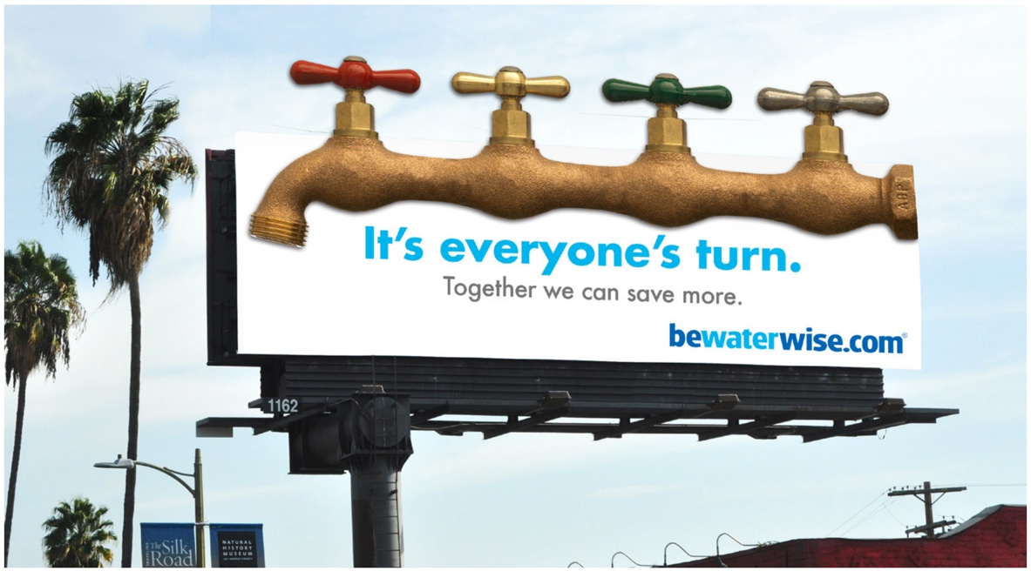

*Figure1: Realistic advertising version*

*Figure2:Screenshot of the program outcome page.*

the faucet will stop dripping water and a red rectangle will pop on the screen saying BE DRIP NOT DROUGHT! The red rectangle and the circle in the background together will form a “🚫” sign trying to let people be aware of running water faucet.

**Usage and interaction**

* Homescreen: When the program starts, there will be a water faucet on the middle of your canvas. Little random sized circle will drop out from the water faucet represent as the water drop dripping.
* User-interaction: We made our program more interactively with the user. The user can stop the water from dripping by pressing their mouse on the switch part of the faucet.
* BE DRIP NOT DROUGHT: Once the user pressed their mouse on the switch, the water will stop dripping from the faucet, and there will be a red rectangle popping out on the canvas with the text saying BE DRIP NOT DROUGHT.

**Architecture**

* Main: Main code for the program which displays all other animations and initialize the size and color for the background. Moreover, this is the part where we initialize the length of the water drip array which will result in the number of water drops created in this program. The canvas shows water drops dripping from a faucet. As the water keeps dripping, a small pool appears below and the water level gets higher and higher. Finally, when the water level reaches a certain level, the water begins to seep into the ground and grow into trees. If you tighten the faucet before the water level reaches a certain level, the end prompt will appear.
* Background:
* Dripping water:
* Pool:
* Tree: